**TERM 1 – 2025**

**BIOLOGY (231/1)**

**FORM TWO CAT**

**Time: 2 Hours**

**MARKING SCHEME**

**INSTRUCTIONS TO CANDIDATES**

1. Write your name, admission number and school in the spaces provided above.
2. Sign and write the date of the examination in the spaces provided above.
3. Answer ALL the questions in the spaces provided on the question paper.
4. Candidates should check the question paper to ascertain that all the pages are printed as indicated and that no questions are missing.
5. Candidates should answer the questions in English.

**FOR EXAMINER’S USE ONLY**

|  |  |  |  |  |  |  |  |  |  |  |  |  |  |  |  |
| --- | --- | --- | --- | --- | --- | --- | --- | --- | --- | --- | --- | --- | --- | --- | --- |
| **1** | **2** | **3** | **4** | **5** | **6** | **7** | **8** | **9** | **10** | **11** | **12** | **13** | **14** | **15** | **16** |
|  |  |  |  |  |  |  |  |  |  |  |  |  |  |  |  |

|  |  |  |  |  |  |  |  |  |  |
| --- | --- | --- | --- | --- | --- | --- | --- | --- | --- |
| **17** | **18** | **19** | **20** | **21** | **22** | **23** | **24** | **25** | **GRAND TOTAL** |
|  |  |  |  |  |  |  |  |  |  |

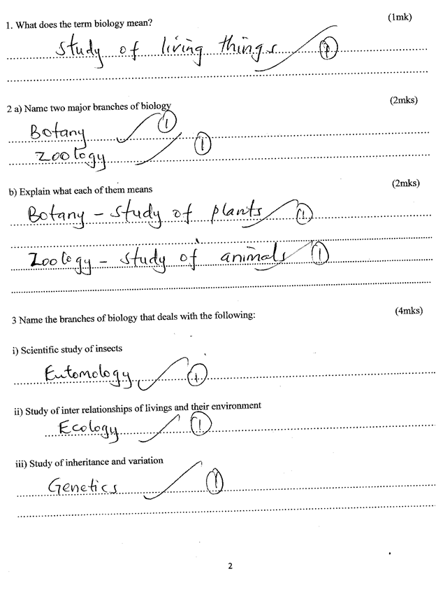

4. a) The science of classification.

b) A group of organisms that can freely/ naturally interbreed to give a fertile (viable ) off spring; 1mk

5. a) Stores /contain hydrolytic enzymes to destruction of worn out organelles/cells tissues/ digestion of bacteria/ pathogens; Acc (-digestion of food/autolysis).

b) Packaging /processing synthesized cell materials/production of lysosomes /secretion of packaged materials.acc (glycoprotein’s/mucus for packaged materials.) 2 mks

  6. a) Attract and trap organisms e.g. a rat;

b) picking up stinging insects ;

7. a) Where specimen is placed;

b) Regulates the amount of light to the specimen;

8.

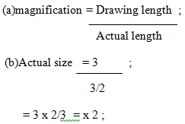

 3 marks

9.(a) Kingdom ;

10. (a)Pooter;  
 (b)Avoid insect being sucked into the mouth of sucker ;

11. Binomial nomenclature

12. a) B;

b) Water molecules;

c) Osmosis;

13. a) Guard cell

b) Thick inner wall and thin outer wall;

Has chlorophyll;

14. a)B Vacuole ;

C Tonoplast ;

D Chloroplast;

b) Cellulose

15. a group of organs working together for a particular function(1mk)

16. Species;

17.a) It is the basic unit of life in an organism; (1mk)

b)3mm = 3000 micrometers

= 3000   = 300 micrometers 2mks

18.a)Monera (1mk)

b)protoctista/protista (1mk)

c)Fungi (1mk)

1. a)Raises /lower the body tube (1mk)

b)Reflects light to the specimen

20. a) Zoology;

b) Botany;

21. Observation;

Drawing;

Analysing;

22. Career choice; eg teacher of Biology

23.a) Irreversible change in mass;

b) Irreversible change in complexity;

24. a) Reproduction;

b) Nutrition;

c) Irritability;

d) Movement/ Sensitivity;

25. Do not destroy the habitat;

Pick up using forceps;

26. a) plants are autotrophs while animals are heterotrophs

b) plants lack elaborate excretory organs while animals posses elaborate excretory organs

27. (a)

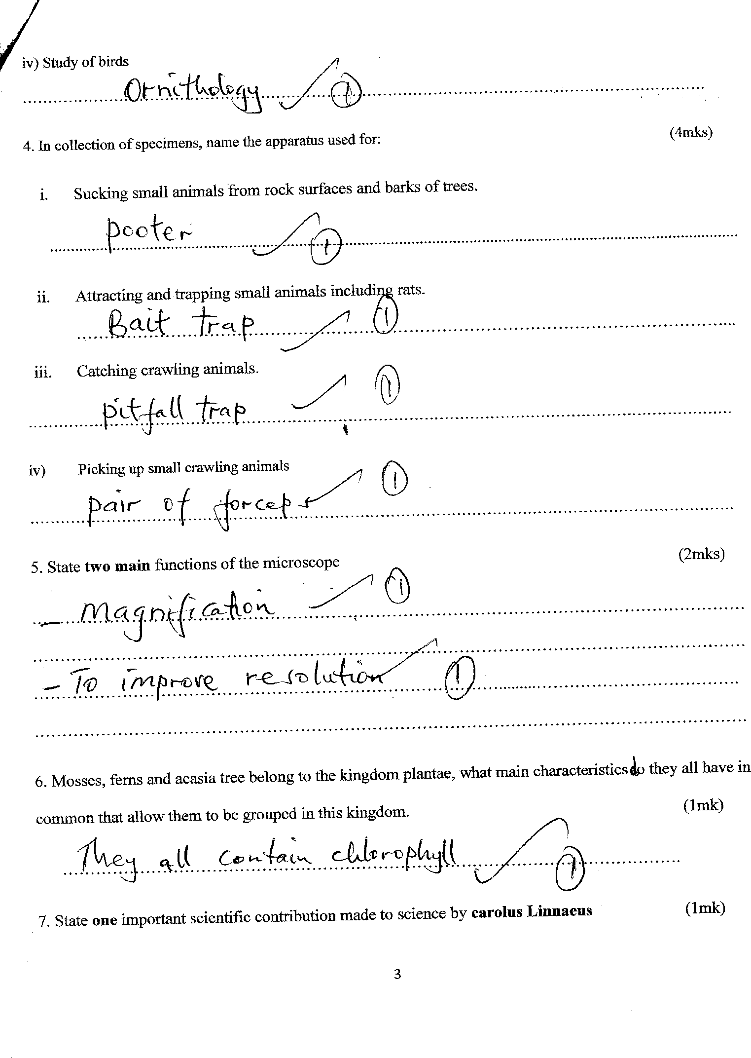

(b)

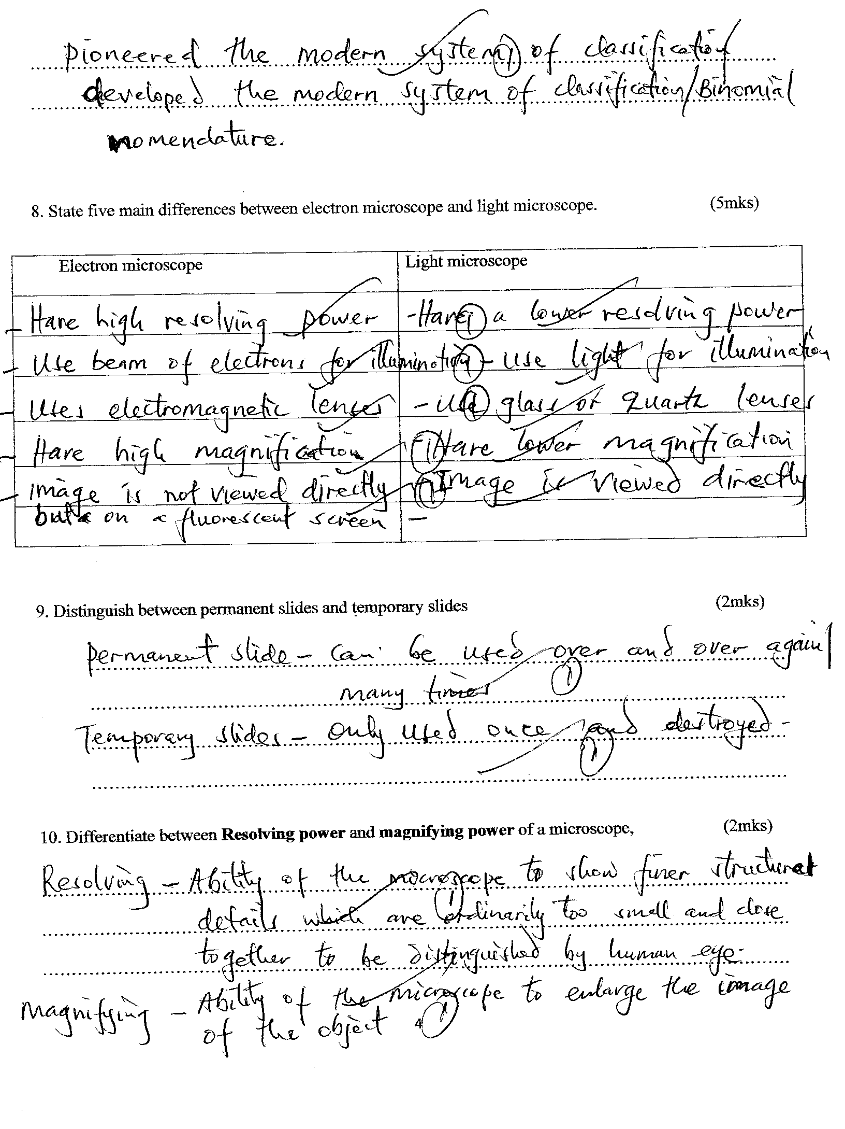

(c)



28.



29.

