**Term 1 - 2025**

**CHEMISTRY(23)**

**FORM TWO CAT**

**Time: 2 Hours**

**Name**: …………………………………………………………. **Adm** **No**: ……………….

**School**: ……………………………………………………….. **Class**: …………………..

**Signature**: …………………………………………………….. **Date**: …………………...

INSTRUCTIONS TO CANDIDATES

1. Write your name and index number in the spaces provided above
2. Sign and write date of examination in the space provided.
3. All working must be clearly shown where necessary.
4. Mathematical tables and silent electronic calculations may be used
5. Answer all questions in English.

For Examiners’ use only

|  |  |  |
| --- | --- | --- |
| Question | Maximum Score | Candidates’s Score |
| 1-22 | 80 |  |

*Candidates should check to ascertain that all pages are printed as indicated and that no questions are missing.*

1. (a) Define Chemistry.           (1mark)

………………………………………………………………………………………………

………………………………………………………………………………………………

………………………………………………………………………………………………

(b) Give two importance of studying Chemistry.         (2marks)

………………………………………………………………………………………………

………………………………………………………………………………………………

………………………………………………………………………………………………

1. (a) Name one frequently abused drug           (1mark)

………………………………………………………………………………………………

………………………………………………………………………………………………

(b) State one long term effect of drug abuse.                       (1mark)

………………………………………………………………………………………………

………………………………………………………………………………………………

1. (a) The following are laboratory apparatus used in Chemistry. Name them and give their uses.

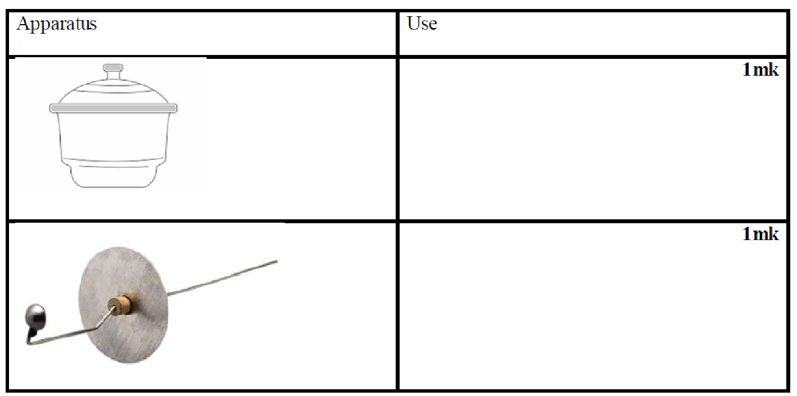

(b) Give one reason why most laboratory apparatus are made of transparent glass.                                                                                                                       (1mark)

………………………………………………………………………………………………

………………………………………………………………………………………………

………………………………………………………………………………………………

1. (a) What is a flame?           (1mark)

………………………………………………………………………………………………

………………………………………………………………………………………………

(b) The following diagram represent a type of flame produced by a Bunsen burner.

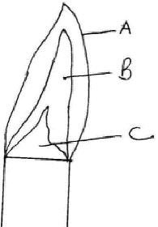

1. Name the type of flame       (1mark)

………………………………………………………………………………………

1. The flame should be put off immediately after use or adjusted to another type of flame. Explain               (2marks)

………………………………………………………………………………………

………………………………………………………………………………………

………………………………………………………………………………………

1. A wooden splint slipped through region B of the above flame laboratory. The splint was burnt as shown in the diagram below.

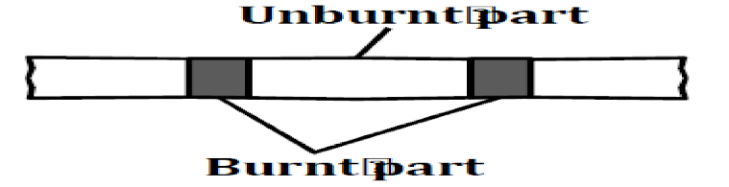

Explain why the splint was burnt the way it is shown in the diagram                   (1mark)

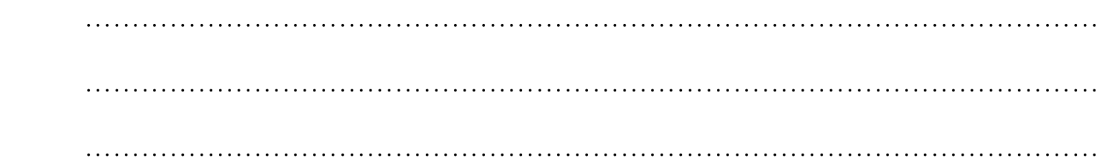

1. Heating solids in a test tube or boiling tube is part of the task a learner is supposed to undertake in a given class experiment. Explain the two precautions a learner should observe               (2marks)

………………………………………………………………………………………………

………………………………………………………………………………………………

………………………………………………………………………………………………

………………………………………………………………………………………………

………………………………………………………………………………………………

1. Draw and give the use of the following apparatus used in the chemistry               (6marks)
2. Thistle funnel

1. Separating funnel

1. Dropping funnel

1. (a) What is a mixture?         (2marks)

………………………………………………………………………………………………

………………………………………………………………………………………………

………………………………………………………………………………………………

………………………………………………………………………………………………

(b) State two physical means of separating a mixture.             (2marks)

………………………………………………………………………………………………

………………………………………………………………………………………………

………………………………………………………………………………………………

(c)A form one student accidentally mixed Sulphur and iron filings. Suggest an appropriate method of separation you would advise him to use to separate the mixture. Give a reason for the choice of your answer.             (2 marks)

………………………………………………………………………………………………

………………………………………………………………………………………………

………………………………………………………………………………………………

(d) Describe how he would use the method named in a above         (3marks)

………………………………………………………………………………………………

………………………………………………………………………………………………

………………………………………………………………………………………………

1. (a) Name two substances that sublime when heated.               (2marks)

………………………………………………………………………………………………

………………………………………………………………………………………………

………………………………………………………………………………………………

(b) Give one reason why dry ice (solid carbon (IV) oxide) is preferred to be    used in cold boxes by ice cream vendor over ordinary ice                 (1mark)

………………………………………………………………………………………………

………………………………………………………………………………………………

1. A form one student wanted to separate and obtain iodine and sodium chloride (common table salt) from a mixture of the two. He set the experimental set up shown below.

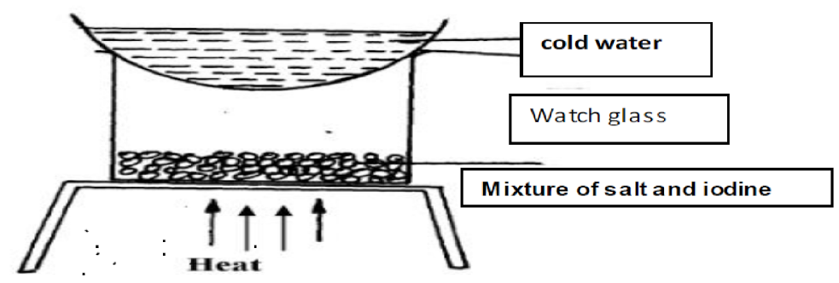

1. The mixture was heated for some time and left to cool. On cooling, shiny black crystals and white crystals were observed on the surface of the watch glass and in the beaker respectively. Name:
2. Shiny black crystals             (1mark)

………………………………………………………………………………………………

………………………………………………………………………………………………

1. White crystals.               (1mark)

………………………………………………………………………………………………

………………………………………………………………………………………………

1. What was the purpose of the cold water in the watch glass?               (1mark)

………………………………………………………………………………………………

………………………………………………………………………………………………

1. Explain how the shiny black crystals on the surface of the watch glass is formed.                         (2marks)

………………………………………………………………………………………………

………………………………………………………………………………………………

………………………………………………………………………………………………

………………………………………………………………………………………………

1. What property of iodine makes it be collected on the watch glass as shown?        (1mark)

………………………………………………………………………………………………

………………………………………………………………………………………………

1. (a) Define the following terms:
2. A saturated solution.       (1mark)

………………………………………………………………………………………………

………………………………………………………………………………………………

………………………………………………………………………………………………

1. Crystallization.         (1mark)

………………………………………………………………………………………………

………………………………………………………………………………………………

………………………………………………………………………………………………

(b) (i) Describe how copper (II) sulphate crystals can be obtained from copper (II) sulphate solution.                        (3marks)

………………………………………………………………………………………………

………………………………………………………………………………………………

………………………………………………………………………………………………

………………………………………………………………………………………………

………………………………………………………………………………………………

     (ii) Give two industrial applications of crystallization as a method of separating soluble substances from their solutions.         (2marks)

………………………………………………………………………………………………

………………………………………………………………………………………………

………………………………………………………………………………………………

1. The following are hazard symbols were observed by a student in one of the stock bottle in chemistry laboratory. Identify the symbols

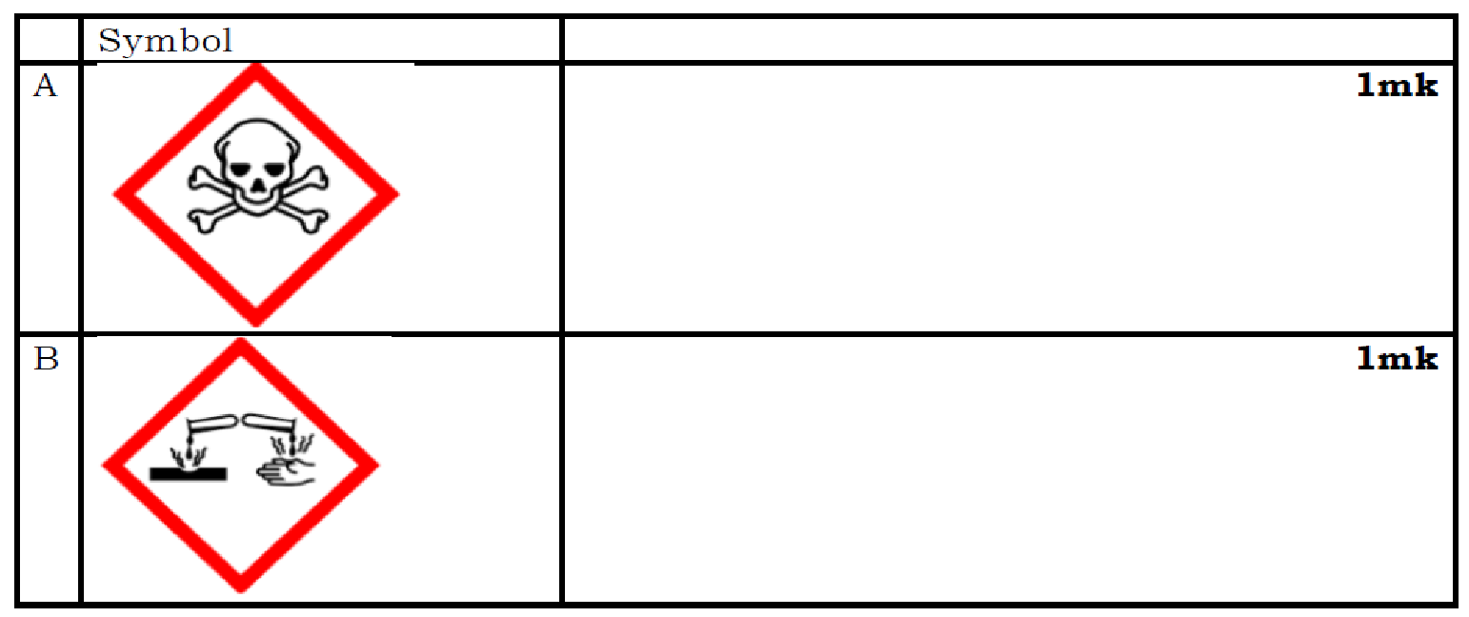

1. State what students should do in case of a major accident such as fire outbreak in the chemistry laboratory           (2marks)

………………………………………………………………………………………………

………………………………………………………………………………………………

………………………………………………………………………………………………

1. Distinguish between prescription drugs and over the counter drugs         (2marks)

………………………………………………………………………………………………

………………………………………………………………………………………………

………………………………………………………………………………………………

………………………………………………………………………………………………

………………………………………………………………………………………………

1. Give the method used in separating the following mixtures             (2marks)
2. Sand and water

………………………………………………………………………………………………

………………………………………………………………………………………………

1. Salt solution

………………………………………………………………………………………………

………………………………………………………………………………………………

1. The following set up was used to separate sand and water. Study it and answer the questions that follows.

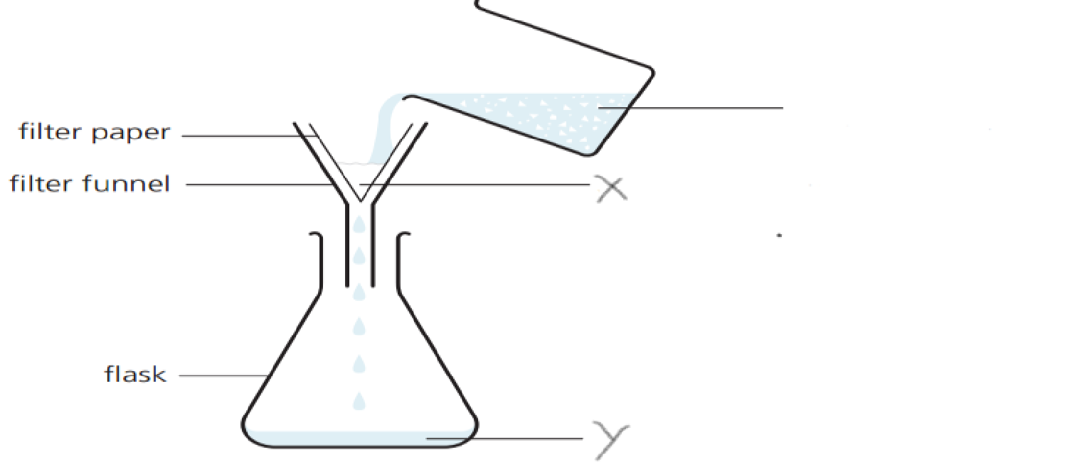

1. Identify the method of separation.               (1mark)

………………………………………………………………………………………………

………………………………………………………………………………………………

1. Give a special name given to solid X and liquid Y.               (2marks)

………………………………………………………………………………………………

………………………………………………………………………………………………

1. State an advantage of this method over decantation.               (1mark)

………………………………………………………………………………………………

………………………………………………………………………………………………

………………………………………………………………………………………………

1. The diagram below represents a Bunsen burner

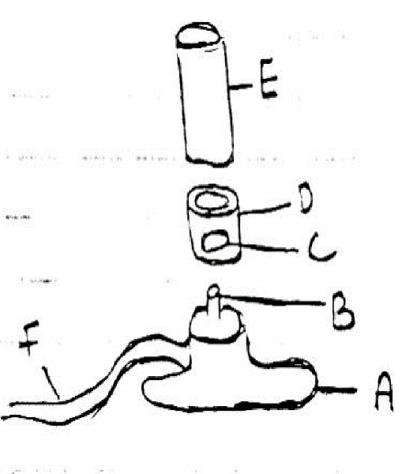

1. Give the name of the parts labeled A, B, C, D, E and F on the diagram           (3marks)

………………………………………………………………………………………………

………………………………………………………………………………………………

………………………………………………………………………………………………

(b) A Bunsen burner can produce two different types of flames under different   conditions.

1. Name the two types of flames produced by a Bunsen burner         (2marks)

………………………………………………………………………………………………

………………………………………………………………………………………………

1. Give 3 differences between the two flames in (i) above         (3marks)

………………………………………………………………………………………………

………………………………………………………………………………………………

………………………………………………………………………………………………

………………………………………………………………………………………………

………………………………………………………………………………………………

………………………………………………………………………………………………

1. Draw and label the most suitable Bunsen burner flame preferred for lighting in the laboratory         (4 marks)

1. Explain why a round bottomed flask is preferred for simple distillation and not a flat bottomed flask           (1mark)

………………………………………………………………………………………………

…………………………………………………………………………………………

……

1. The diagram below shows the relationship between the physical state of matter.

study it and answer the questions that follows.

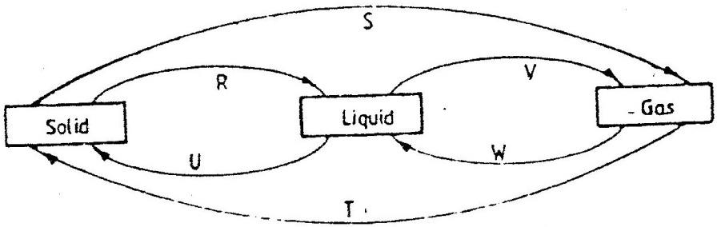

1. Identify the processes R, V, W and U. (2marks)

………………………………………………………………………………………………

………………………………………………………………………………………………

1. Name one element which undergo the process represented by S and T. (1mark)

………………………………………………………………………………………………

………………………………………………………………………………………………

1. (a) Define the term “striking back” as applied to a Bunsen burner flame. (1mark)

………………………………………………………………………………………………

………………………………………………………………………………………………

………………………………………………………………………………………………

1. Explain how striking back can be controlled in case it occurs. (1mark)

………………………………………………………………………………………………

………………………………………………………………………………………………

1. A patient was given tablets with prescription 2 x 3 on the envelope. Clearly outline how the patient should take the tablets. (1 mark)

………………………………………………………………………………………………

………………………………………………………………………………………………

………………………………………………………………………………………………

1. Two samples of equal volumes of water were put in 250cm³ beaker and heated for 10 minutes. Sample 1 registered a higher temperature than sample 2.

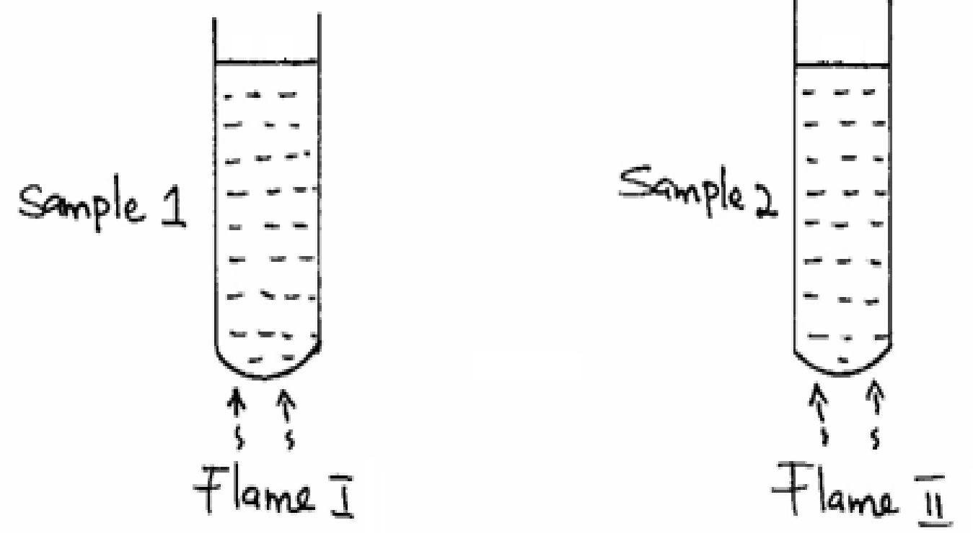

         State the conditions under which flame I is produced in Bunsen burner. (1 mark)

………………………………………………………………………………………………

………………………………………………………………………………………………

1. The apparatus below was used to separate a mixture of liquid A and B.

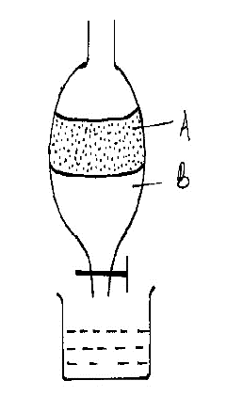

State two properties of the liquids that make it possible to separate them using such apparatus.                                                                                       (2marks)

………………………………………………………………………………………………