**Term 1 - 2025**

**DRAWING AND DESIGN (449)**

**FORM TWO**

**Time: 1½ Hours**

**MARKING SCHEME**

1. State five reasons studying drawing and design as a subject (5 marks)

* Express ideas through the use of freehand sketching and technical drawings;
* Read and interpret working drawings;
* Distinguish between good and bad design;
* Appreciate the constraints involved in designing;
* Find solutions to design problems;
* Make simple models using available materials;
* Demonstrate an awareness of the career opportunities available in the related areas of technical education and training.

1. Briefly define the following terms. (2mks)
2. Technical drawing:,

* is **a detailed, precise diagram or plan that conveys information about how an object functions or is constructed**.

1. Design.

* Design is the process of imagining and planning the creation of objects, systems,or modifying systems

1. List four type of drawing templates found in drawing office. (4mks)

* [Architectural Templates](https://www.draftingsuppliesdew.com/supplies/architectural-templates)
* [Arrowhead Templates](https://www.draftingsuppliesdew.com/supplies/arrowhead-templates)
* [Circle Templates](https://www.draftingsuppliesdew.com/supplies/circle-templates)
* [Electrical and Electronic Templates](https://www.draftingsuppliesdew.com/supplies/electrical-and-electronic-templates)
* [Ellipse Templates](https://www.draftingsuppliesdew.com/supplies/ellipse-templates)
* [Flow Chart Templates](https://www.draftingsuppliesdew.com/supplies/flow-chart-templates)
* [General Purpose Templates](https://www.draftingsuppliesdew.com/supplies/general-purpose-templates)

1. a). State the sizes of the following drawing papers. (4mks)
2. A4 210 x 297
3. A3 297 x 420
4. A2 420 x 594
5. A1 594 x 840

b). state where each of the following types of lines are used (5mks)

*Type of line*  *uses*

1. Bold and continuous line visible outline
2. Thin and continuous line construction lines
3. Bold and continuous irregular line short break
4. Thin short dashes hidden details
5. Thin chain lines centreline
6. (a)Give one reason why the following are used in drawings (2marks)
7. lettering

It provides brief but clear information, which is not easily conveyed by the drawing.

1. Symbols and abbreviations

To eliminate too many notes

(b)State the two main classes of drawings (2mks)

1. Technical drawing
2. Artistic drawing
3. Fill in the blank spaces with the correct type of drawing associated with the following fields in technical drawing.(5mks)

|  |  |  |
| --- | --- | --- |
|  | FIELD | TYPE OF DRAWING |
| 1 | Construction industry | Building drawing |
| 2 | Mechanical industry | Machine drawing |
| 3 | Building industry | Architectural drawing |
| 4 | Ship industry | Marine drawing |
| 5 | Aircraft industry | Aeronautical drawing |

1. List four aims of technical drawings. (4mks)
2. ………………………………………………Speed
3. ……………………………………………….Neatness
4. ………………………………………………Accuracy
5. ………………………………………………..Technique
6. State five general maintenance on drawing instruments (5 marks)
7. Keep the instruments dry.
8. Keep mechanical drawing instruments in correct adjustment.
9. Treat all instruments as delicate.
10. Periodically clean the drawing boards, set squares and Tee squares with moist cloth.
11. Do not use for cutting.
12. (a)What is dimensioning. (1mks)

Is indicating actual measurements along the lines that they represent on scaled drawing

1. Use sketches to illustrate the difference between datum and chain dimensioning. (4 marks)

1. Sketch how the following pencils are sharpened. (2mks)
2. HB pencil H pencil

 

1. Construct the following angles using a pair of compass , a pencil and a ruler only (10 marks)
2. 600

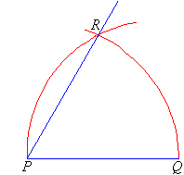

1. 300

1. 900

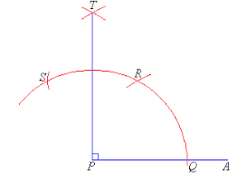

1. 37.50

1. 750

1. Construct a square whose diagonal is 65mm (6mks)



1. From the given line AB, illustrate how a line can be proportionally sub- divided into 10 equal portions. (6mks).

A B

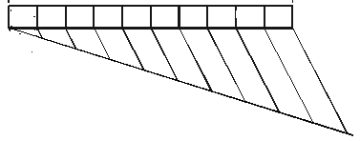

1. Construct a kite when given the lengths of the diagonals as 71 mm and 53mm and the point of intersection is 53mm from one end of the longer diagonal. (6mks)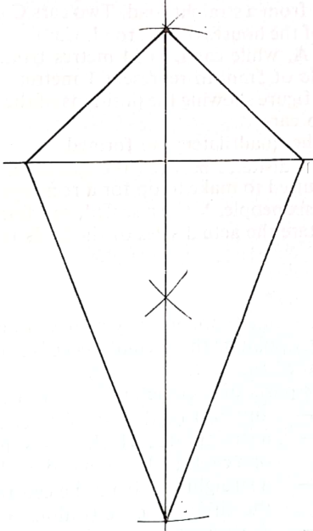
2. Construct a triangle with a base measuring 62mm, an altitude of 50mm (6mks)



1. Construct a triangle when given the base as 60mm and two base angles as 1200 and 300. (6mks)

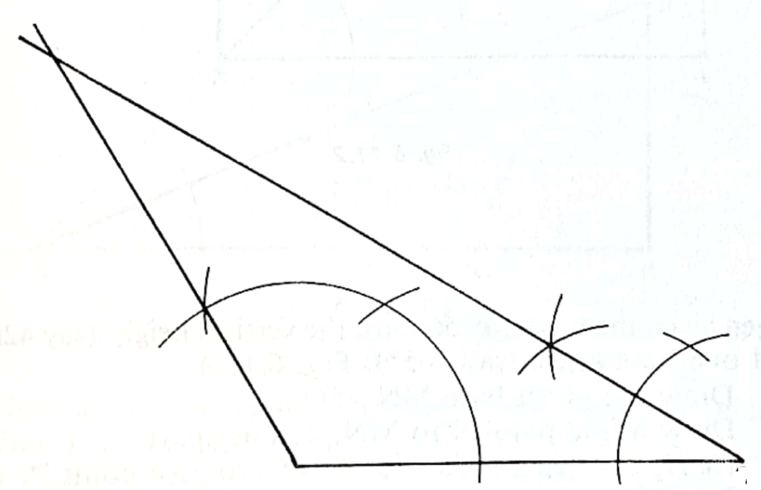

1. Draw the following views of the block given below. (15 marks)
2. Front Elevation
3. End elevation
4. The plan

