**Term 1 – 2025**

**MID TERM EXAM**

**GEOGRAPHY (312)**

**FORM TWO (2)**

**Time: 2 ½ Hours**

MARKING SCHEME

**SECTION A**

**1. a) Define the term environment (2marks)**

*Environment is the external surrounding of living organism and have influence on their behavior*

**(2 x1)= 2mks**

**b) Give three branches of geography (3marks)**

* *Physical geography*
* *Human and economic geography*
* *Practical geography*  **3 x 1 = 3mks**

**2. a) Name two layers of discontinuity that are part of the interior of the earth. (2marks)**

* Mohorovicic discontinuity.
* Gutenberg discontinuity. **(2 × 1)= 2 mks**

**b) State three characteristics of the outer core in the interior structure of the earth. (3mks)**

*✓It is composed of molten rock materials.*

*✓The main minerals are iron and nickel.*

*✓It has a depth of about 2100km to 2900 km thick.*

*✓Has a temperature ranging from 3700 C to 5000 C*

*✓Has an average density of 10.0 gm/cc to 12.3 gm/cc* . **(any first 3× 1=3 marks)**

**3. (a) Define the term 'Rocks' (2 marks)**

* *Rock is a collection of mineral particles that make part of the earth’s crust.*

**2 x1= 2mks**

**(b) Give the classification of rocks according to the origin or mode of formation (3 marks)**

* *Igneous rocks*
* *Sedimentary rocks*
* *Metamorphic rocks*

*3 x1= 3mks*

**4. (i) Name the plates of the lithosphere based on plate tectonic theory (3marks)**

* *N. America plate - South America plate*
* *African plate - Eurasian plate*
* *Australian plate - Antartic plate*
* *Pacific plate - Carribbean plate*
* *Adriatic plate - Fiji plate*
* *Arabian plate - Nazca plate*

**(ii) State the evidences for the continental drift theory (2marks)**

* *Topographic evidence; for example, the Jigsaw of the continents. South Africa fits into Africa so well.*
* *Geological evidence; there is a close structural resemblance and many geological similarities especially between the eastern coast of South America and the western coast of Africa.*
* *Tectonic evidence; the distribution of Fold Mountains and volcanic zones which are comparable from one side of the ocean to the other.*
* *Climatological evidence; only continental drift can account for the apparent reversals of climate that have glacial deposits in the Congo Basin and other parts within the tropics.*
* *Biological evidence; this evidence is based on the study of fossils showing the distribution of plants and animals in the past compared with the present day distribution of certain plants and animal species whose occurrence seems quite inexplicable unless continental drifting is invoked.*
* *Palaeo-magnetism evidence; This is the most influential evidence of continental drift. When rocks solidify, they are magnetised in the direction of magnetic North at that time. By studying the magnetism of ancient rocks, it is possible therefore determine the where on the surface they were originally formed.*

**Any 2 x 1 = 2mks**

**5. a) Name two types of faults associated with faulting. (2marks)**

*✓Normal faults*

*✓Reverse faults*

*✓Tear/shear/slip faults*

*✓Thrust fault*

*✓Anticlinal fault* **(2×1 = 2 Mks)**

**(b) State three effects of faulting on drainage of an area. (3 marks**)

*✓ Down warping due to faulting may lead to formation of depressions which may be*

*filled by water to form lakes.*

*✓ Fault lines due to fracturing of crustal rocks may change the course of river making*

*the river to start flowing along the fault line forming faulting guided drainage*

*pattern.*

*✓ Fault scarps forming across rivers course may lead to formation of waterfalls.*

*✓ Faulting may lead to formation of lines of weakness in earth’s crust which becomes*

*passages for hot water from the underground to the earth’s surface to form hot*

*springs and geysers****.***

**(3×1mrks)**

**SECTION B**

**6.** Study the data in the below and answer the questions that follow;

Kenya’s export crops in 2015 to 2019 (in ‘000’ tones)

|  |  |  |  |  |  |
| --- | --- | --- | --- | --- | --- |
| **Crops**  **Year** | **2015** | **2016** | **2017** | **2018** | **2019** |
| **Tea** | 40 | 51 | 50 | 57 | 56 |
| **Coffee** | 33 | 42 | 56 | 49 | 50 |
| **Wheat** | 26 | 37 | 54 | 44 | 44 |
| **TOTAL** | **99** | **130** | **160** | **150** | **150** |

1. **Calculate the mean of Tea from 2015 to 2018**

*Total= 198/4 = 49.5 tonnes*

**(2mks)**

1. **Apart from tables mention three other methods of data presentation (4 marks)**

* *Graphs*
* *Pie charts*
* *Tally*
* *Dot maps*
* *Choropleths*
* *Proportional circles*

1. **(i)Give advantages of using simple bar graphs in presenting data. (3 marks)**

* *Easy to draw*
* *Gives clear visual impression*
* *Easy to read*
* *Easy to interpret*

1. **You are planning to carry out a field study in a weather station.**
2. **Give four reasons why you would carry out a pre-visit of the area of study. (4 marks)**

* *To assess the suitability of the study area*
* *To help draw up objectives and hypothesis*
* *To help prepare route map*
* *To help design a work schedule*
* *Help identify probable problems and how to solve them*
* *To help estimate the cost of the study*
* *To help identify suitable data collection methods*
* *To help identify appropriate equipment/tools to be carried*

1. **What are the advantages of preparing a working schedule during the field study? (4 marks)**

* *Enables plan activities to be carried out systematically*
* *Allows for proper use of the available time*
* *Enables for the assessment of the progress of the field work*
* *It enables the estimation of total time required for the study*
* *It confines researcher to the scope of the topic*
* *It assumes that all areas are adequately covered*

1. **Outline three follow-up activities you are likely to engage in after the field study. (3 marks)**

* *Displaying photographs*
* *Group discussion*
* *Writing a report*

1. **State the importance of studying geography using fieldwork (5marks)**

* It enables collection of samples for future reference
* Enable one to get first-hand information
* Allows for easy recall
* Makes learning real/meaningful
* Helps learners understand better theoretical concepts taught in class/teaching becomes easier
* Helps students develop skills of data collection
* Makes learning interesting

**7. (a) Differentiate between vulcanicity and volcanicity (2 marks)**

Vulcanicity is the process through which gaseous, liquid and solid igneous materials are injected into the crust of the earth or ejected onto its surface while volcancity is the process through which gaseous, liquid and solid igneous materials are ejected onto its surface.

(b) **Apart from the sill, list other intrusive volcanic features (2 marks)**

* Dyke - Batholith - Laccolith
* Lopolith - Phacolith

(c)  **State the three classifications volcanoes (6 marks)**

*Active volcano*; This is a volcano which has erupted or is thought to have erupted within recent time (500 years ago).

*Dormant volcano*; This refers to a volcano that has not been known to erupt and yet is not thought to be extinct and still shows some limited activity in the form of fumaroles.

*Extinct volcano*; This refers to a volcano that shows no sign of further eruption and much of the original structure or appearance may have been destroyed by denudation.

1. **Use the diagram below to answer the questions that follow.**

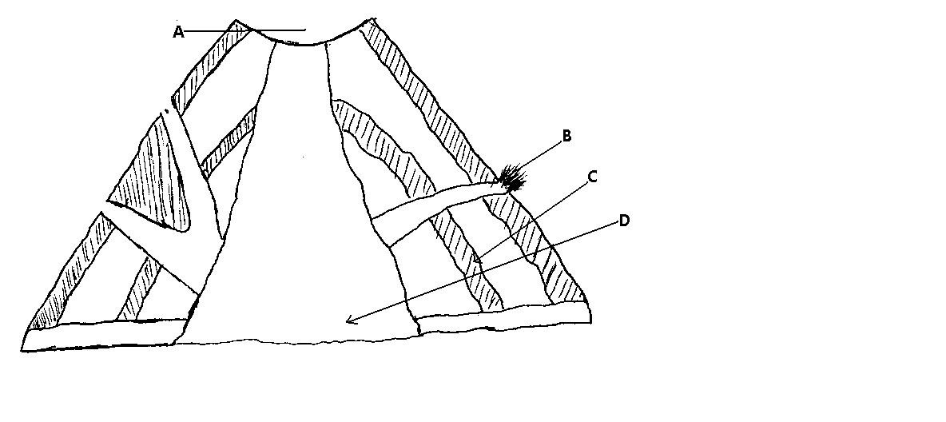

**(i) Identify the type of volcano represented above. (1mk)**

* + *Type of volcano – composite volcano.*

**(ii) Name the parts labelled A, B, C, D, (2mks)**

*Parts marked A –crater / caldera*

*B-cone let*

*C-layers of ash/ cinder/ pyroclasts*

*D-pipe/vent/ dyke.* **½ x 4 =2mks**

***(iii) Explain how the above volcanic feature is formed. (4mks)***

*Formation of a composite volcano*

* + *Formed from a central vent*
  + *When a fault occurs that extents to the mantle, magma is forced out under pressure.*
  + *The material constructs a mountain of alternating layers of ash and lava.*
  + *The eruption are intermittent i.e. the ash comes out in one season and lava during the next season.*
  + *The lava is acidic hence flow for a short distance before cooling /lava cools around the rent.*
  + *The top of the volcano is blown off to form a crater.*
  + *Cone lets are formed due to blockage in the main vent.*

***(e) Explain four importance of Vulcancity (8marks)***

* *Vulcan city has produced fertile soil for agriculture activities which is the backbone of the Kenya economy.*
* *Vulcanicity has offered good / ideal siter for geothermal power generation e.g. Olkaria which generates electricity used in industries.*
* *Vulcan city has produced mountains well watered mountain slopes have provided base for forests e.g. Mt Kenya forest where lumbering is undertaken.*
* *Some volcanic feature e.g. crater hot spring and geysers attract tourists who bring in foreign exchange.*
* *Volcanic mountains are source of rivers which provide water for irrigation/settlement in the lower regions.*
* *Vulcanicity has yielded valuable rocks which are used for building and construction*

8. (a) **Define the term 'Earthquake'. (2marks)**

* *An earthquake is a sudden and rapid shaking of the ground due to displacement of rocks beneath the earth's surface.*

(**b) State 3 causes of earthquakes (3 marks)**

* *Some earthquakes are due to volcanic explosions.*
* *Majority of earthquakes and severe ones are due to faulting.*
* *Earthquake are also caused by the collision of tectonic plates.*
* *Other earthquakes are due to folding which cause stress on rocks.*
* *Human’s action such as the use of explosives e.g. in mining may also earthquakes.*
* *Other earthquakes are caused by isostatic adjustment and gravitative pressure.*

**(c) Define the following terms (6marks)**

1. *Seismic focus - This is the spot in the earth's crust where the earthquake originates.*
2. *Epicentre - This is the point on the earth's surface vertically above the focus.*
3. *Seismograph - Also known as seismometer, seismograph refers to a delicate scientific instrument used to detect and record an earthquake kilometre away.*

**(d) i. Explain the difference between:**

*(.) Primary(P) waves and Secondary (S) waves (2marks)*

* *Primary waves behave like sound waves i.e. each particle vibrates to and fro in the direction of propagation. They penetrate both in solid and liquid substances. WHILE*
* *Secondary waves are like ocean or light waves where the motion of each particle is at right angle to the direction of propagation. They only penetrate through solid substances.*

(.) Richter scale and mercalli scale (2 marks)

*Richter scale is used to measure the size of an earthquake (i.e. its magnitude). It is based on instrument recordings. WHILE*

*Mercalli scale is used to measure the intensity and is based on observed effect of damage and changes in the earth's surface.*

(ii) **Explain the effects of earthquakes on physical and human environment (10marks)**

* *Earthquakes results into great loss of life.*
* *It leads to destruction of property especially buildings.*
* *It alters the appearance of the landscape.*
* *It may trigger off a landslide or an avalanche causing some danger.*
* *Earthquakes may destroy communication lines and transport lines.*