**TERM 1 – 2025**

**MIDTERM**

**HOMESCIENCE (441/1)**

**FORM TWO (2)**

**MARKING SCHEME**

**SECTION A (40 MARKS)**

1. Ways of using old papers in the house.

* Cleaning windows.
* Lining shelves.
* Wrapping fragile items.
* Stuffing shoes to maintain shape.
* Padding a table to avoid heat damage.
* Placing muddy boots or shoes.
* Lighting a fire.

(Each correct mark ½ a mark, ½ x 2 = 1mark)

1. Advantages of open drainage system.

* It is easy to clean.
* It is cheap to construct.
* It is easy to unblock if blocked.
* It can be used even in areas with no running water.

(Each correct point 1 mark, 1 x 2 = 2marks)

1. Vectors that cause communicable diseases.

* Snails
* Flies
* Mosquitoes
* Fleas
* Black flies

(Each correct point ½ mark, ½ x 2 = 1 marks)

1. Qualities of a good clothes drying rack.

* It should not rust.
* It should be strong to hold weight of wet clothes.
* It should be foldable for easy storage.
* Should be waterproof.
* It should be stable to avoid toppling over.
* It should be light in weight so that it can be carried easily.

(Each correct point 1 mark, 1 x 3 = 3marks)

1. Reasons for turning pockets inside out when washing clothes.

* To empty the pockets.
* To clean out dirt from hidden areas in the pocket.
* To check for any undone seams and repair.

(Each correct point 1 mark, 1 x 2 = 2marks)

1. Items that should be dried flat during laundry.

* Knitted/crocheted items.
* Items made of wool.
* Loose coloured items.

(Each correct point ½ mark, ½ x 2 = 1mark)

1. Identifying the following stitches.

(a) 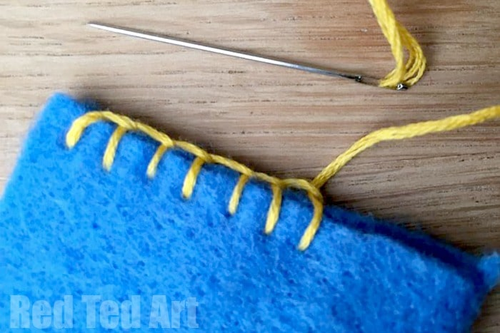 Loop stitch

(b) 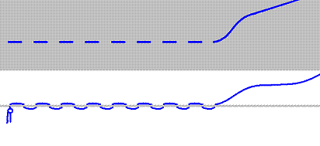 Running stitch.

Even tacking

(Each correctly identified stitch ½ mark, ½ x 2 = 1mark)

1. Ways of reducing the spread of tuberculosis.

* Wearing a face mask correctly and consistently.
* Early identification and treatment of persons with tuberculosis.
* Ensuring good ventilation in enclosed space.
* Avoiding careless spitting.
* Observing hand hygiene especially after coughing or using tissues/handkerchiefs.
* Vaccinating new-born babies against tuberculosis.

(Each correct point 1 mark, 1 x 2 = 2marks)

1. Mention **three** ways students make their environment dirty.

* Dropping papers/litter all over the compound.
* Throwing left over food on pavements/ground.
* Brushing teeth outside in trenches or spitting out toothpaste on the ground and hedges.
* Pouring dirty water on hedges and plants.

(Each correct point 1 mark, 1 x 3 = 3marks)

1. Differentiate between boiling and steaming.

* In boiling the food being cooked is completely submerged in water while in steaming the food is not in contact with the water but is cooked by steam produced through boiling water.

(Each correctly stated to show the difference 1 mark, 1 x 2 = 2marks)

1. Ways one can get worm infestation.

* Eating undercooked meat.
* Poor hand hygiene.
* Walking bare footed on soil that may have
* Drinking contaminated water.
* Contact with contaminated faeces.
* Poor handling and care of pets.

(Each correct point ½ mark, ½ x 4 = 2marks)

1. Symbols to illustrate the laundry instructions.



* Do not bleach



* Dry on the hanging line



* Use a cool iron



* Dry clean



1. Laundry processes carried out on white cottons and linens that are not carried out on loose coloured clothes.

* Soaking.
* Use of friction method.
* Wringing out water.
* Damping of clothes for finishing.
* Boiling.

(Each correct point ½ mark, ½ x 2 = 1mark)

1. Identifying the cooking method illustrated by each of the pictures. (2mks)

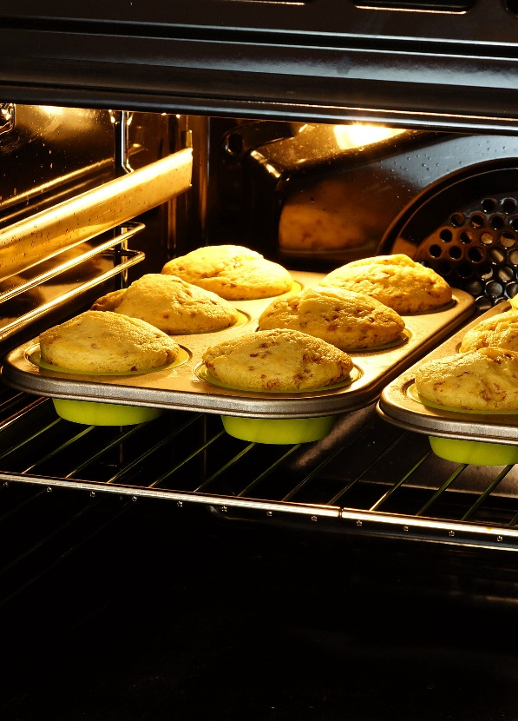 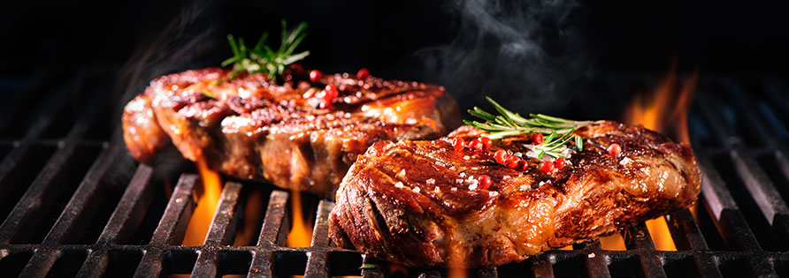

**Baking**  **Grilling/accept roasting**

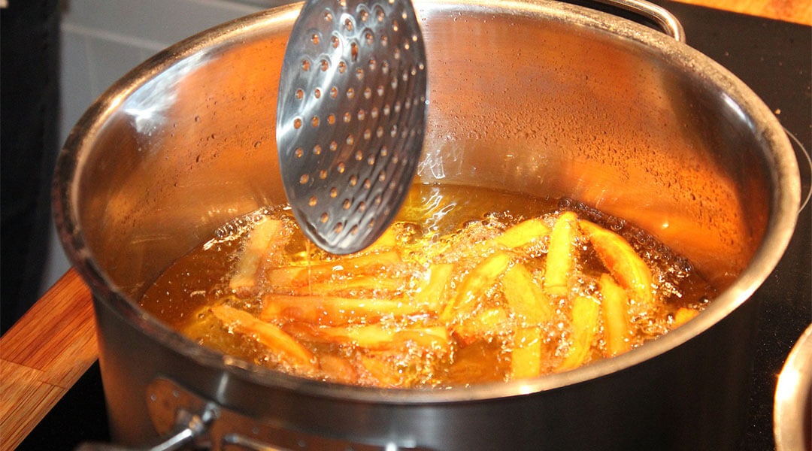 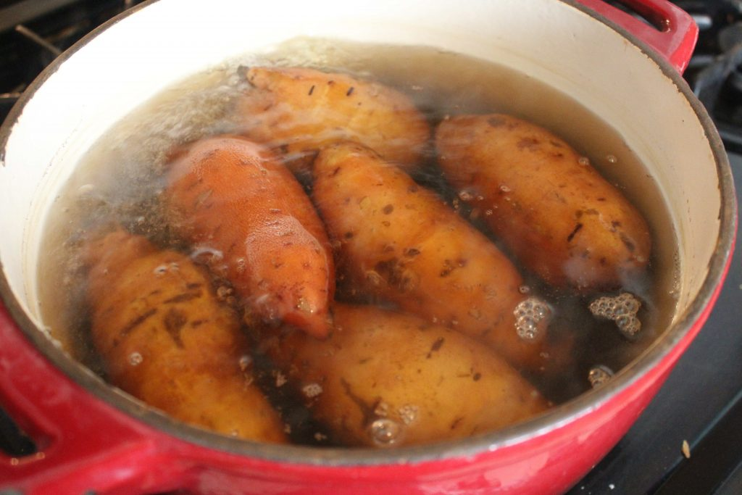 **Deep fat frying** **Boiling**

(Each method correctly identified ½ mark, ½ x 4 = 2marks)

1. Name **two** stitches used in neatening raw edges.

* Loop stitch
* Blanket stitch
* Overcasting
* Machine zigzag
* Machine overlock

(Each correct stitch ½ mark, ½ x 2 = 1mark)

1. Differentiating between the **two** main methods of repairing tears in a garment.

* Darning. This is used on straight tears whose edges can be put back together easily and the torn area supported by use of running stitches.
* Patching. This is done on a tear that is jagged or there is a hole. It is also used in weak areas in a garment. The repair involves use of a separate piece of fabric that is stitched on the area to be repaired.

(Correct identification ½ mark each, correct differentiation ½ mar each, 1 x 2 = 2mks)

1. Ways of maintaining the colour of white cotton clothes.

* Drying the clothes out in the sun for natural bleaching.
* Washing the clothes separately from coloured clothes.
* Boiling the clothes.
* Drying the clothes away from loose coloured clothes.
* Bleaching with chemical bleaches when discoloured.
* Washing the clothes regularly to avoid accumulation of dirt that can discolour the clothes.

(Each correct point 1 mark, 1 x 3 = 3marks)

1. Name **two** diseases that can be prevented through correct wearing of a face mask.

* Tuberculosis
* COVID 19
* Influenza
* Common Cold

(Each correct disease ½ mark, ½ x 2 = 1mark)

1. Identify **three** signs of worm infestation in a child.

* Pain in the abdomen/stomach.
* Blood in stool.
* Dark coloured stool due to intestinal bleeding.
* Irritating cough.
* Excessive hunger.
* Weight loss.
* Distended abdomen.
* Lethargy/Tiredness.
* Worms in stool.
* Itching on the skin or the anal area.

(Each correct point 1 mark, 1 x 3 = 3marks)

1. Equipment used in finishing clothes.

* Irons
* Ironing boards
* Mangle
* Sleeve board
* Seam roll
* Needle board (for ironing fabric with nap or pile)

(Each correct equipment ½ mark, ½ x 4 = 2marks)

1. Qualities of a fabric suitable for making a handkerchief.

* Strong to withstand frequent washing.
* Absorbent to absorb mucus.
* Colour fast to avoid loss of colour when washed.
* Withstands high temperatures to kill germs during ironing or boiling.
* Soft to avoid injuring the nose.

(Each correct point 1 mark, 1 x 3 = 3marks)

**SECTION B (20 MARKS)**

1. Procedure of cleaning a terrazzo finished corridor.

* Collect the equipment and materials needed (½).
* Sweep(½) the floor to remove loose dirt. Collect the dirt and dispose correctly(½).
* Scrub(½) the floor a small portion(½) at a time using warm(½) soapy(½) water, use circular motion(½) when scrubbing and overlap(½) the sections.
* Rinse each portion(½) by wiping with a clean(½) floor cloth(½) wrung(½) from clean(½) water.
* Wipe the floor dry(½) with a clean well wrung floor(½) cloth.
* Clean the equipment and store(½).

(14 correct steps well written ½ mark. ½ x 14 = 7marks)

1. Describe how you will clean your discoloured white canvas shoes.

* Collect equipment and materials required(½).
* Protect(½) the working surface with old newspapers(½).
* Remove mud/dust(½).
* Scrub(½) the shoes with a brush using warm(½) soapy(½) water containing a bleach(½).
* Rinse thoroughly(½) in warm(½) clean(½) water.
* Give a final(½) cold(½) rinse.
* Flick(½) the shoes to remove excess water.
* Incline(½) the shoes in the shade(½) with the toe(½) end up.
* When half dry(½) apply whitener(½) evenly.
* Turn the shoes so that the toe end faces down(½).
* When completely dry, stuff (½)the shoes to maintain shape.
* Store in a clean place(½).
* Clean the equipment and clear up the working area(½).

(14 correct steps well written ½ mark. ½ x 14 = 7marks)

1. Procedure of laundering a cotton /polyester school blouse/shirt.

* Collect all materials needed (½).
* Empty the pocket(½).
* Soak(½) briefly in cold(½) water.
* Wash in warm(½) soapy(½) water using gentle friction(½).
* Rinse thoroughly in clean warm(½) water.
* Give a final(½) cold(½) rinse.
* Dry out in the shade(½) on the line secured with pegs(½).
* When slightly damp(½) iron(½) with a relatively hot iron(½).
* Air(½).
* Fold/hang and store(½).
* Clear up the working area(½).

(12 correct steps well written ½ mark. ½ x 12 = 6marks)

**SECTION C (40 MARKS)**

1. Rules to follow in stain removal.

* Remove stains when fresh. Stains become stubborn with age and are thus easier to remove when fresh,
* Use mild agents first before trying strong agents. Stain removal agents may harm fabric and some agents are expensive so mild agents may be cheaper and less harmful to clothes.
* Work from outside to the inside. This reduces chances of spreading the stain.
* Rinse the area thoroughly after stain removal. This removes all the stain removal agents that could weaken the garment if left on the fabric.
* Remove stains before putting clothes in water. Some stains become less visible when the fabric is wet and thus may not be identified easily for removal. Water may also make some stains to spread.

(½ mark for statement, 1 mark for explanation. 1½ x 4 = 6marks)

1. Processes that can destroy loose coloured clothes during laundry.

* Using hot water. This makes the colour to run out more.
* Using friction method. The rubbing makes the fabric shed more colour.
* Soaking the garment. Water loosens the colour making it to come out a lot more.
* Mixing differently coloured clothes. The colours run into each other and destroy the garments.
* Drying the clothes on the line. The colours run into each other or drain and get darker at the lower edge of the garment.
* Ironing on the right side. This makes the colour fade.
* Drying the clothes out in the sun. this makes colours fade.

(Correct statement 1 mark each, 1 x 5 = 5maks)

1. Rules to observe when steaming food.

* Bring the water to boil before placing the food. This allows food to steam from the first moment of placing and ensures that food is not slowly heated during steaming.
* Food should not be in contact with water. Steamed food should be cooked without getting in contact with water to avoid leaching out nutrients.
* Keep the pot boiling. This will ensure a continuous flow of steam for the food being steamed.
* Cover the pot tightly. This locks in the steam ensuring the food cooks faster.
* Refill with boiling water. This will ensure that the flow of steam is continuous and the temperature does not come down.
* Check frequently to avoid boiling the pot dry. Water can evaporate and dry up and this will lead to burning of the steamed food and damage to the pot.

(Each well-reasoned point 1 mark, 1 x 5 = 5marks)

1. Ways that the use of an item affects its laundry process.

* Items used in the kitchen. Dish cloths and kitchen cloths are used to dry utensils and clean kitchen surfaces respectively and need frequent washing and disinfection to kill microorganisms. These items are also disinfected through boiling and not using chemical disinfectants because they used on plate or surfaces used to prepare food.
* Personal items. Inner wear and handkerchiefs must be washed separately from other garments to avoid any infections transmitted through mixing items from different people. Outer clothes may also harbour micro-organisms that can be picked up by inner wear and lead to infections.
* Floor cloths and dusting clothes. These are used to remove dirt from surfaces. They are usually dirtier than other items and thus should be washed separately to ensure they are thoroughly cleaned and do not make other items dirty.

(Each correct statement ½ mark, well discussed 1 ½ marks 2 x 2 = 4mks)

1. Reasons for sorting clothes during laundry.

* To avoid mixing of colours when loose coloured and white/fast coloured clothes are washed together.
* To wash clothes according to their fibre content so that the correct washing procedure is followed.
* To separate clothes according to use so that each group is given appropriate attention.
* To group clothes according to the degree of soiling. This reduces chances of staining clothes and ensures that dirtier clothes are given the attention they need to remove dirt. It also saves on water as less soiled clothes are washed first and the same water used to wash the dirtier lot.
* To reduce spread of infections. Clothes used by the sick are washed separately from the others and this reduces chances of spreading infections. Such clothes are also disinfected before washing to avoid infecting the person washing the clothes.

(Each point correctly outlined 1 mark, 1 x 4 = 4marks)

1. Points to consider when choosing shoes.

* Use of the shoes. Shoes for daily wear should have a comfortable heel to ensure comfort in use. Sports shoes should be absorbent/breathable and have good treads to ensure they absorb sweat and also avoid slipping during games.
* Size. Shoes should fit comfortably to avoid getting corns and bunions or even deforming the feet.
* Material used to make the shoes. The material used should be strong to last long. It should also be suitable for the type of use the shoe is needed for.
* Style. One needs to buy shoes that go with their personality. Some people are trendy and thus need a shoe that goes with that personality, other people are more of functional and thus need to buy shoes that will serve them timelessly.
* Budget. Shoes range in price from relatively cheap to very expensive. One should buy shoes that are within their budget plan.
* Design. Buy a shoe that is well designed to fit the shape of one’s foot.

(Each correct statement ½ mark, explanation 1 mark, 1½ x 4 = 6marks)

1. Reasons for repairing clothes.

* To increase their life. Well repaired clothes are restored to use and thus do not need to be disposed.
* To keep them neat. Well repaired clothes look neat thus avoiding an untidy and careless look if clothes are not repaired.
* To avoid further damage. When clothes are torn or worn or if buttons are loose, the damage will get worse with tears extending, worn areas tearing and loose buttons falling off if repairs are not done.
* For decency. Some tears may expose parts of the body that should be covered that leading to indecent exposure.
* To save on money. When clothes are repaired, they are in use for longer thus saving on money that could have been used to buy new items if repairs were not done.

(Each correct point clearly stated 1 mark, 1 x 4 = 4marks)

1. Properties of cotton that make it suitable for making bath towels.

* Cotton is absorbent. Towels need to be absorbent to be able to dry water from the body after bathing.
* Cotton is a strong fibre. Towels need to be strong so that they can withstand frequent washing and friction when washing to remove dirt when washing. Being strong, the towel will also last for a long time.
* Cotton can withstand high temperatures. Towels may occasionally need to be boiled to sterilise especially those used in hotels and hospitals.
* Cotton does not generate static electricity. This allows one to rub/pat oneself after bathing without the towel generating static electricity that would make it cling to the body.
* It is free of chemicals. This means that it can be used safely by people with delicate skins, allergies and eczema without fear of damaging their skin.
* Cotton takes dyes easily. This means one can get a bath towel in exciting colours that suit one’s preference and personality.

(Each correct statement ½ mark, explanation 1 mark, 1½ x 4 = 6marks)

2. Factors to consider when buying a house other than cost.

* Size and composition of the family. This is to ensure that the house has enough rooms to accommodate the number of family members in their different gender comfortably.
* Reliability of the seller. A house is a costly investment and one must ensure that the seller is straightforward to avoid losing money.
* Neighbourhood. The house should be situated in a safe area. This ensures that the family feels secure when living in the area.
* Agreed payment plan. Many people buy houses on mortgage. It is important that the buyer thinks trough the payment plan so that they do not fall trough the payments and lose the house to the mortgage provider.
* Future prospects. A house is an asset. Buy a house whose value would appreciate with time other than depreciate with time.
* Design. Buy a house tat is well designed for comfortable living. The house should also not have spaces that are unnecessary and add no value to the house. The design should also be aesthetically pleasing.
* Location/site of the house. Buy a house in an area that is welcoming, peaceful, well drained and has pleasant views.
* Quality of construction. Get a quantity surveyor to check on the quality of construction. This ensures that the house is structurally safe. It also assures the owner that they are spending money on something worth the cost.

(Each correct statement ½ mark, explanation 1 mark, 1½ x 4 = 6marks)

1. Reasons why students should sleep well at night.

* It helps one to concentrate better in class during the day and avoid drifting off mentally.
* It leads to better performance in school scores because the brain is rested thus improving memory.
* It leads to better decision making. This reduces cases of carelessness and accidents that are caused by lack of concentration.
* It reduces stress and incidences of moodiness aggression and depression.
* It improves immunity thus reducing incidences of illnesses and being away from school.
* It reduces truancy. Teenagers who are sleep deprived may be tempted to stay out of school so as to rest during the day.
* Helps fuel the brain and the body. Teenagers are growing and need more sleep in order to have healthy growth.

(Each correct point clearly outline 1 mark, 1 x 5 = 5marks)

1. Benefits of good hand hygiene in school going children.

* Reduces incidences of diarrhea in children that can lead to serious illness or even death.
* Helps reduce spread of communicable diseases such as COVID 19, typhoid and cholera.
* With reduced illness, children are able to attend to school and minimize need of staying away from school due to poor health.
* Children grow better because they are not frequently ill. Frequently ill children spend their protein on repair instead of growth and thus their growth is slower.
* Hand hygiene means children are in school more thus improving chances of better performance in school.
* It form life time habits of healthy practices.

(Each correct statement 1 mark, 1 x 4 = 4marks)

1. Explain **five** challenges one may face living in a dirty and disorganized house.

* Accidents. A disorganized house will easily lead to accidents as family members can trip and fall over items strewn on the floor or wrongly placed.
* Pests. Dirt attracts pests like cockroaches and rats and these quickly find a hiding place in poorly stored clothes or items.
* Diseases. Dirt can attract insects and vectors that carry diseases leading to illness in the family.
* Promotes confusion. One’s surrounding can influence mental health. A cluttered space leads to cluttering in the mind.
* Stress. Disorganization can lead to increased stress levels in individuals living in the house as the house is less relaxing.
* Lateness. A messy house means it takes longer to get anything needed thus people end up being late.
* Allergic reactions. A messy environment creates an environment where mites and mould may grow leading to more allergies in the home.
* Lethargy. Clutter clogs the mind making one feel tired and less active.
* Psychological unease. An untidy house make one feel anxious and fearful of receiving guests.
* Difficult to keep clean. A messy environment is more challenging to keep clean. The more dirt is not removed the harder it gets to remove dirt that is fixed,

(Each point well explained 1 mark, 1 x 5 = 5marks)

**THIS IS THE LAST PRINTED PAGE**