**Term 1 - 2025**

**PHYSICS (232)**

**FORM TWO**

**Time: $2 Hours$**

**MARKING SCHEME**

**Instructions to Candidates**

* *Write your name, admission number, class and signature in the spaces provided at the top of the page.*
* *Answer* ***ALL*** *the questions in the spaces provided.*
* *All work MUST be clearly shown.*
* *This paper consists of* ***7*** *printed pages.*
* *Candidates should answer the questions in English and check to ensure that no question(s) is missing.*

**FOR EXAMINER’S USE ONLY**

|  |  |  |
| --- | --- | --- |
| **QUESTIONS** | **MAXIMUM SCORE** | **CANDIDATE’S SCORE** |
| 1-18 | **51** |  |

***Answer all the questions in this section in the spaces provided.***

1. Mechanics is one of the branches of Physics. State what it deals with. (1Mark)

*It deals with the study of motion under the influence of force**√*

1. The diagram in figure 1 below shows a section of a meter rule measuring the size of an object. What is the size of the length of the object shown? (1mark)

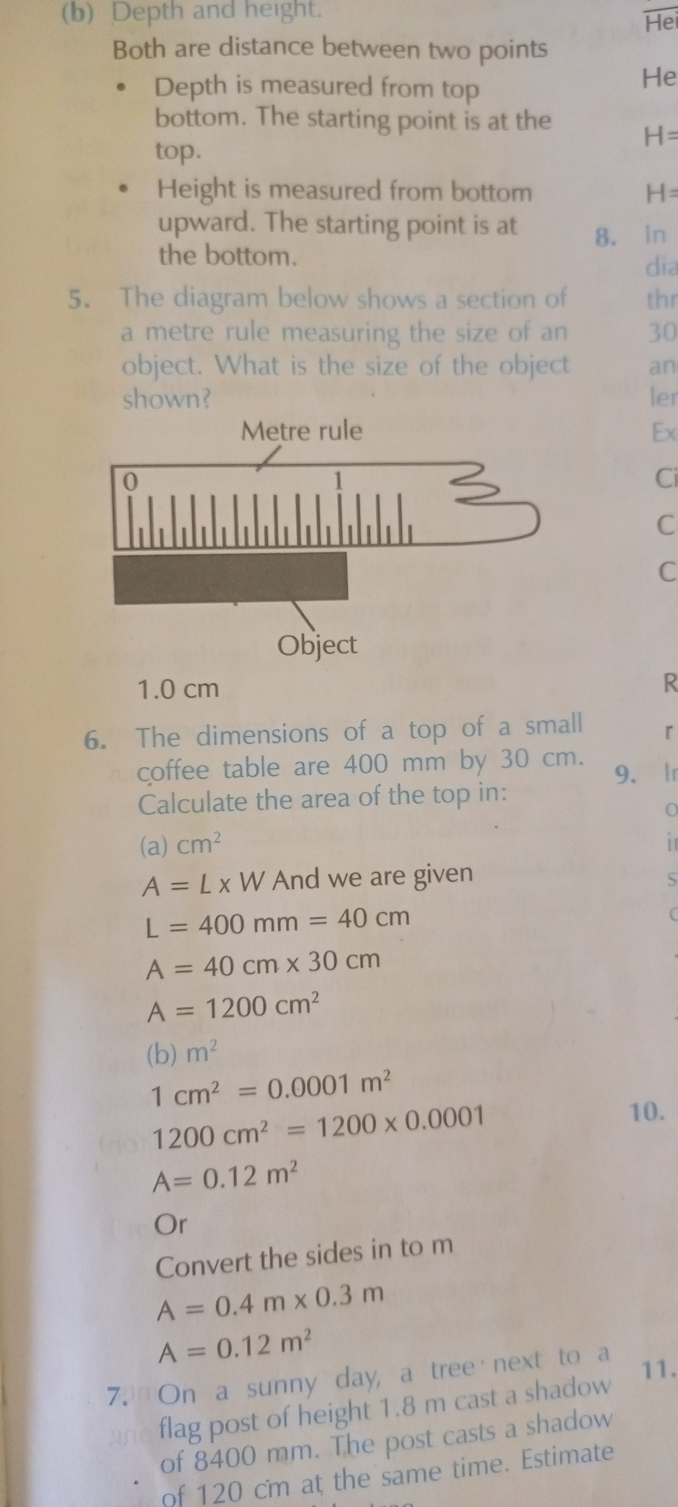

*Figure 1*

*1.0cm**√ -ensure 1decimal place and correct unit, cm.*

1. Name three instruments in a Physics laboratory that can be used to measure volume of a liquid. (3marks)

-Burette, *√* Pipette, *√* Volumetric flask, *√* Measuring cylinder*√- any 3*

1. Students used a stop watch to take time in a bread eating competition. The display on the stop watch was 01:24:90. Express the time taken in SI units. (2marks)

$$1×60Seconds =60 Seconds$$

$60+24=84seconds$*√*

$84.90seconds.$*√*

1. When preparing tea, water is mixed with milk.500cm3 of water is mixed with 618 g of milk. Calculate the density of tea given that the density of water and milk is 1000kg/m3.

(3marks)

$$Mass of water=1 ×500=500g$$

$$Total mass=500g+618g=1118g√$$

$$Volume of milk=\frac{mass}{density}=\frac{618}{1}=618{cm}^{3}$$

$Total volume=618+500=1118{cm}^{3}$*√*

$$Density of mixture=\frac{total mass of mixture}{total volume of mixture}=\frac{1118g}{1118{cm}^{3}}=1g/{{cm}^{3}}√$$

1. The volume of one drop of a liquid was found to be 0.045 ml. If 30 drops were delivered by a burette from an initial reading of the liquid being 11.4 ml, find the final reading of the liquid. (3marks)

$Volume of 30 drops=30×0.045=1.35ml$*√*

$Final reading=Initial volume+volume of 30 drops=11.4+1.35√=12.75ml$*√*

1. Explain why displacement method is unsuitable for determining the volume of irregular shaped solids such as wood blocks , ice and charcoal pieces? (2 mark)

* The solids float on water; they can not displace liquid*√*
* They are absorbent*√*
* The ice melts/dissolves in water*√*

1. Define force and state its SI units. (2 marks)

* Force refers to a push or a pull *√*. The SI unit of force is the newton (N). *√*

1. Estimate the area of the irregular surface shown in figure below. Use the scale,

$Small square=1{Km}^{2}$ (3marks)

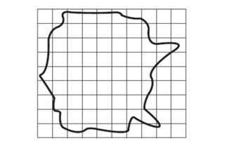

*Figure 2*

The number of complete squares = 39 *√*.

Number of incomplete squares = 30

These are equal to = 15 complete squares*√*.

Therefore, the number of complete squares = 39 + 15 = 54

Hence, the estimated area of the surface = 54 × $1{Km}^{2}$ = 54 ${Km}^{2}$*√*.

1. Give reasons why the following rules apply in the Physics laboratory (3marks)
2. Never plug foreign objects into electrical sockets.

Apart from damaging the socket, this can also cause an electric shock. *√*.

1. Never taste, eat or drink anything in the laboratory.

This is to avoid the risk of consuming dangerous or poisonous materials or substances. *√*

1. While working in the laboratory, windows and doors should be kept open.

This is to prevent inhalation of dangerous materials or gases and also to allow for easy escape/evacuation in case of an emergency. *√*

1. Identify the branch of science that studies matter and its relation to energy. (1mark)

Physics. *√*

1. A drug manufacturer gives the mass of an active ingredient in a tablet as 5mg. Express this quantity in kilogram. (1 mark)

$\frac{5}{1000}=0.005Kg$. *√*

1. In an experiment to determine the density of sand using a density bottle, the following measurements were recorded;

$$Mass of empty density bottle=43.2g$$

$$Mass of density bottle full of water=66. 4g$$

$$Mass of density bottle with some sand=67.g$$

$$Mass of density bottle with the sand filled up with water=82.3g$$

Use the above data to determine the following:

1. Mass of the water that completely filled the density bottle. (1mark )

$66.4g-43.2g=23.2g$. *√*

1. Volume of water that completely filled the density bottle (2mark )

$volume=\frac{mass}{density}=\frac{23.2}{1}=23.2{cm}^{3}$.*√*

1. Volume of the density bottle (1mark )

$volume of density bottle=volume of water that completely fills botle=23.2{cm}^{3}$*√*

1. Mass of sand (1mark)

$67.5g-43.2g=24.3g$*√*

1. Mass of water that filled the space above the sand (1mark)

$82.3g-67.5g=14.8g$*√*

1. Volume of sand (2mark)

$23.2-14.8$*√*

$=8.4{cm}^{3}$*√*

1. Density of the sand. (2marks)

$Density=\frac{24.3}{8.4}$*√*

$=2.893g/{{cm}^{3}}$*√*

1. Identify the types of forces responsible in the following situatons, (5marks)

when;

1. Polished shoes rapidly attract dust due to charges left on them during brushing.

Electrostatic force*√*

1. Lighting a match stick

Frictional force *√*

1. Swimmers and boats float

Upthrust force*√*

1. a ball thrown upwards returns back to the ground

Gravitational force*√*

1. a steel razor blade placed carefully on the surface of water floats but sinks when a detergent is added to the water.

Surface tension force. *√*

1. The diagram below shows a system of three forces acting on an object. What is the resultant force? State the direction in terms of left or right. (3marks)

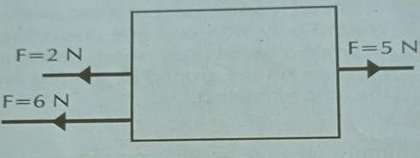

*Figure 3*

$2N+6N=8N$*√*

$8N-5N=3N$*√*

*To the left√*

1. State with reason why an object on earth has a higher weight than on the moon while the mass remains the same. (2marks)

The gravitational pull on earth is greater than that of the moon. *√*

Mass is constant/ it does not vary from place to place. *√*

1. A man has a mass of 70kg. Calculate:
2. His weight on earth, where the gravitational field strength is 10N/kg. (2marks)

$w=mg=70×10$*√*

$=700N$*√*

b) His weight on the moon, where the gravitational field strength is 1.7N/kg. (2marks)

$W=mg=70×1.7$*√*

$=119N$*√*

1. State two measurements you would take in an experiment to determine the upthrust of an object which is immersed in kerosene. (2marks)

Weight of object in air*√*

Weight of object in the kerosene*√*

**END.**