Term 1 - 2025
PHYSICS (232)
FORM TWO CAT
Time: $2 Hours$

Name: …………………………………………………………. Adm No: ……………….
School: ……………………………………………………….. Class: …………………..
Signature: ……………………………………………………... Date: …………………...

Instructions to Candidates
- Write your name, admission number, class and signature in the spaces provided at the top of the page.
- Answer ALL the questions in the spaces provided.
- All working MUST be clearly shown.
- This paper consists of 9 printed pages.
- Candidates should answer the questions in English and check to ensure that no question(s) is missing.

FOR EXAMINER’S USE ONLY

QUESTIONS | MAXIMUM SCORE | CANDIDATE’S SCORE
1-18 | 51

Answer all the questions in this section in the spaces provided.
- Mechanics is one of the branches of Physics. State what it deals with. (1Mark)
………………………………………………………………………………………………………………………………………………………………………………………………………………

- The diagram in figure 1 below shows a section of a meter rule measuring the size of an object. What is the size of the length of the object shown? (1 mark)
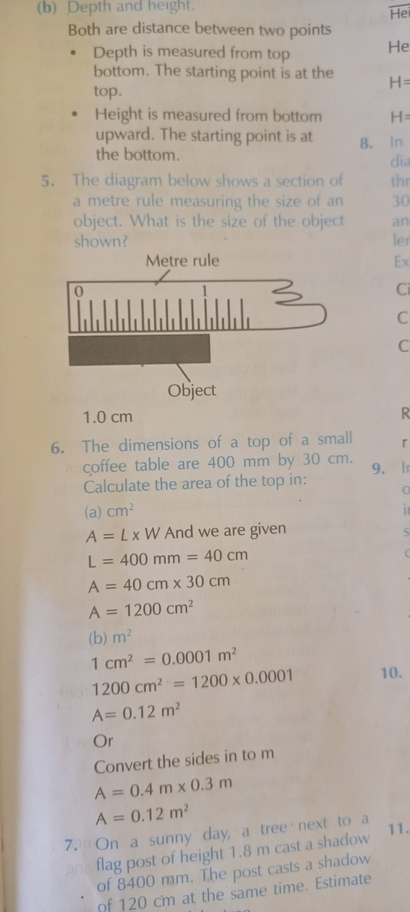
Figure 1
………………………………………………………………………………………………………

- Name three instruments in a Physics laboratory that can be used to measure volume of a liquid. (3marks)
………………………………………………………………………………………………………………………………………………………………………………………………………………………………………………………………………………………………………………………………………………………………………………………………………………………………

- Students used a stopwatch to take time in a bread eating competition. The display on the stopwatch was 01:24:90. Express the time taken in SI units. (2marks)
………………………………………………………………………………………………………………………………………………………………………………………………………………………………………………………………………………………………………………………

- When preparing tea, water is mixed with milk.500cm³ of water is mixed with 618 g of milk. Calculate the density of tea given that the density of water and milk is 1000kg/m³.
(3marks)
………………………………………………………………………………………………………………………………………………………………………………………………………………………………………………………………………………………………………………………………………………………………………………………………………………………………………………………………………………………………………………………………………
- The volume of one drop of a liquid was found to be 0.045 ml. If 30 drops were delivered by a burette from an initial reading of the liquid being 11.4 ml, find the final reading of the liquid. (3marks)
………………………………………………………………………………………………………………………………………………………………………………………………………………………………………………………………………………………………………………………………………………………………………………………………………………………………………………………………………………………………………………………………………………………………………………………………………………………………………………

- Explain why displacement method is unsuitable for determining the volume of irregular shaped solids such as wood blocks, ice and charcoal pieces? (2 mark)
………………………………………………………………………………………………………………………………………………………………………………………………………………………………………………………………………………………………

- Define force and state its SI units. (2 marks)
………………………………………………………………………………………………………………………………………………………………………………………………………………………………………………………………………………………………

- Estimate the area of the irregular surface shown in figure below. Use the scale,
$Small square=1{Km}^{2}$ (3marks)

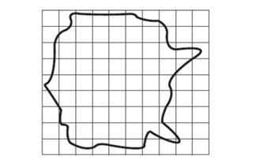
Figure 2
………………………………………………………………………………………………………………………………………………………………………………………………………………………………………………………………………………………………………………………………………………………………………………………………

- Give reasons why the following rules apply in the Physics laboratory (3marks)
- Never plug foreign objects into electrical sockets.
………………………………………………………………………………………………………………………………………………………………………………………………

- Never taste, eat or drink anything in the laboratory.
………………………………………………………………………………………………………………………………………………………………………………………………

- While working in the laboratory, windows and doors should be kept open.
………………………………………………………………………………………………………………………………………………………………………………………………
- Identify the branch of science that studies matter and its relation to energy. (1mark)
………………………………………………………………………………………………………………………………………………………………………………………………
- A drug manufacturer gives the mass of an active ingredient in a tablet as 5mg. Express this quantity in kilogram. (1 mark)
………………………………………………………………………………………………………………………………………………………………………………………………

- In an experiment to determine the density of sand using a density bottle, the following measurements were recorded.
$$Mass of empty density bottle=43.2g$$
$$Mass of density bottle full of water=66. 4g$$
$$Mass of density bottle with some sand=67.g$$
$$Mass of density bottle with the sand filled up with water=82.3g$$
Use the above data to determine the following:
- Mass of the water that completely filled the density bottle. (1mark )
………………………………………………………………………………………………………………………………………………………………………………………………
- Volume of water that completely filled the density bottle (2mark )
………………………………………………………………………………………………………………………………………………………………………………………………

- Volume of the density bottle (1mark )
………………………………………………………………………………………………………………………………………………………………………………………………

- Mass of sand (1mark)
………………………………………………………………………………………………………………………………………………………………………………………………

- Mass of water that filled the space above the sand (1mark )
………………………………………………………………………………………………………………………………………………………………………………………………

- Volume of sand (2mark )
………………………………………………………………………………………………………………………………………………………………………………………………

- Density of the sand. (2marks)
………………………………………………………………………………………………………………………………………………………………………………………………
- Identify the types of forces responsible in the following situatons, (5marks)
when;
- Polished shoes rapidly attract dust due to charges left on them during brushing.
………………………………………………………………………………………………………………………………………………………………………………………………

- Lighting a matchstick
………………………………………………………………………………………………………………………………………………………………………………………………

- Swimmers and boats float
………………………………………………………………………………………………………………………………………………………………………………………………

- a ball thrown upwards returns back to the ground.
………………………………………………………………………………………………………………………………………………………………………………………………
- a steel razor blade placed carefully on the surface of water floats but sinks when a detergent is added to the water.
………………………………………………………………………………………………………………………………………………………………………………………………

- The diagram below shows a system of three forces acting on an object. What is the resultant force? State the direction in terms of left or right. (3marks)
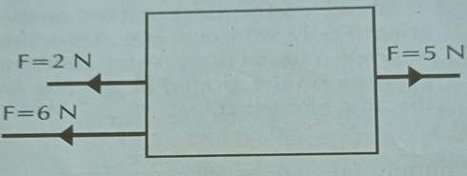
Figure 3
………………………………………………………………………………………………………………………………………………………………………………………………………………………………………………………………………………………………
- State with reason why an object on earth has a higher weight than on the moon while the mass remains the same. (2marks)
………………………………………………………………………………………………………………………………………………………………………………………………………………………………………………………………………………………………………………………………………………………………………………………………
- A man has a mass of 70kg. Calculate:
- His weight on earth, where the gravitational field strength is 10N/kg. (2marks)
………………………………………………………………………………………………………………………………………………………………………………………………………………………………………………………………………………………………

b) His weight on the moon, where the gravitational field strength is 1.7N/kg. (2marks)
………………………………………………………………………………………………………………………………………………………………………………………………………………………………………………………………………………………………
- State two measurements you would take in an experiment to determine the upthrust of an object which is immersed in kerosene. (2marks)
………………………………………………………………………………………………………………………………………………………………………………………………………………………………………………………………………………………………………………………………………………………………………………………………

END.

